**Develop a linear regression model for forecasting time series data**

**EX:No.3**

**DATE:28/02/25**

**AIM:**

To develop a Linear Regression model for forecasting time series data by leveraging lag features to predict future values.

**ALGORITHM:**

1. Load Data – Read the dataset and set the 'Date' column as the index.
2. Feature Engineering – Create lag features (Lag_1, Lag_2, etc.) from the 'Close' price.
3. Handle Missing Values – Remove NaN values created by lagging.
4. Split Data – Divide into training (80%) and testing (20%) sets.
5. Train Model – Fit a Linear Regression model using lag features as predictors.
6. Make Predictions – Use the trained model to forecast future stock prices.
7. Evaluate & Visualize – Compute MAE, MSE, R² score and plot actual vs. predicted values.

**CODE:**

import pandas as pd

import numpy as np

import matplotlib.pyplot as plt

from sklearn.model_selection import train_test_split

from sklearn.linear_model import LinearRegression

from sklearn.metrics import mean_absolute_error, mean_squared_error, r2_score

# Load the dataset

file_path = 'AAPL.csv' # Replace with your dataset path

data = pd.read_csv(file_path)

# Convert 'Date' to datetime and set it as index

data['Date'] = pd.to_datetime(data['Date'])

data.set_index('Date', inplace=True)

# Selecting 'Close' price for forecasting

ts = data[['Close']]

# Create lag features for time series forecasting

ts['Lag_1'] = ts['Close'].shift(1) # Lag of 1 day

ts.dropna(inplace=True) # Remove NaN values from shifting

# Splitting into training and testing sets

train_size = int(len(ts) * 0.8) # 80% training, 20% testing

train, test = ts[:train_size], ts[train_size:]

# Prepare X (features) and y (target)

X_train, y_train = train[['Lag_1']], train['Close']

X_test, y_test = test[['Lag_1']], test['Close']

# Train Linear Regression model

model = LinearRegression()

model.fit(X_train, y_train)

# Make predictions

y_pred = model.predict(X_test)

# Evaluate the model

mae = mean_absolute_error(y_test, y_pred)

mse = mean_squared_error(y_test, y_pred)

r2 = r2_score(y_test, y_pred)

# Print evaluation metrics

print(f"Mean Absolute Error (MAE): {mae:.4f}")

print(f"Mean Squared Error (MSE): {mse:.4f}")

print(f"R-squared (R²): {r2:.4f}")

# Plot actual vs. predicted values

plt.figure(figsize=(12, 6))

plt.plot(test.index, y_test, label="Actual Prices", color='blue')

plt.plot(test.index, y_pred, label="Predicted Prices", color='red', linestyle='dashed')

plt.xlabel("Date")

plt.ylabel("Stock Price")

plt.title("AAPL Stock Price Prediction using Linear Regression")

plt.legend()

plt.show()

**OUTPUT:**

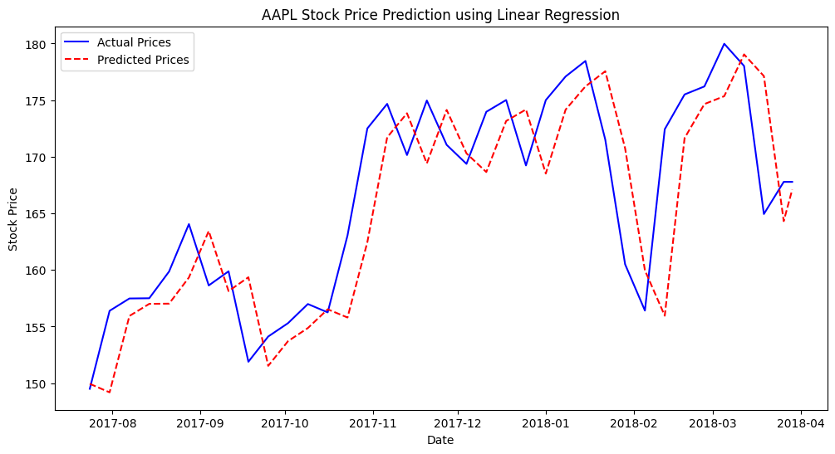

Mean Absolute Error (MAE): 4.2930

Mean Squared Error (MSE): 30.6977

R-squared (R²): 0.5916

**RESULT:**

Thus the program has been completed and verified successfully.